**@Input**

**Custom Property Binding : User for sending value from parent to child component**

**Demo1:**

**Child.html**

<p>{{review}}</p>

**Child.ts**

import { Component, OnInit, Input } from '@angular/core';

@Input() review:number;

**Parent.html**

<app-child [review]="num"></app-child>

**Parent.ts**

num:number=10

**Demo2: Multiple Values**

**Child.html**

<p>{{student.rno}}:{{student.name}}</p>

**Child.ts**

@Input() student:{rno:number, name:string};

**Parent.html**

<app-child *ngFor ="let i of ary" [student]="i"></app-child>

**Parent.ts**

ary=[{rno:10,name:"Rachana"},{rno:11,name:"Beena"}]

Demo3: Show Employee Data with Eno, Ename, EDOB, ESalary,EContact

**Child.html**

<p>{{employee.eno}} {{employee.ename}} {{employee.eDOB}} {{employee.eSalary}}

{{employee.eContact}}</p>

**Child.ts**

@Input() employee:{eno:string, ename:string, eDOB:string,eSalary:number,eContact:number};

**Parent.html**

<app-child *ngFor ="let i of Employee" [employee]="i"></app-child>

**Parent.ts**

Employee=[{eno:"E01", ename:"Tejas", eDOB:"3/4/1995",eSalary:30000,eContact:9998887776},

{eno:"E01", ename:"Tejas", eDOB:"3/4/1995",eSalary:30000,eContact:9998887776},

{eno:"E01", ename:"Tejas", eDOB:"3/4/1995",eSalary:30000,eContact:9998887776},

{eno:"E01", ename:"Tejas", eDOB:"3/4/1995",eSalary:30000,eContact:9998887776},

{eno:"E01", ename:"Tejas", eDOB:"3/4/1995",eSalary:30000,eContact:9998887776}]

**@Output**

**Custom Event Binding: Changing Value by event between parent and child component**

**Demo1**

child.component.html

<div>

<button (click)="onClick()">Click Me</button>

</div>

child.component.ts

import { Component, OnInit, Output, EventEmitter } from '@angular/core';

export class ChildComponent implements OnInit {

@Output() notify=new EventEmitter<string>();

onClick()

{

this.notify.emit("Message From Child");

}

}

parent.component.html

<div>

<h1>Parent Title</h1>

<p>{{showMessage}}</p>

<app-child (notify)="onNotifyClick($event)"></app-child>

</div>

parent.component.ts

import { Component, OnInit } from '@angular/core';

export class ParentComponent implements OnInit {

showMessage="Message From Parent";

onNotifyClick(message:string)

{

this.showMessage=message;

}

}

**Demo 2**

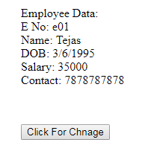 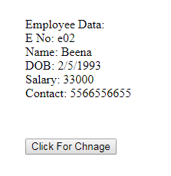

**After Click**

**Child.ts**

import { Employee } from 'src/app/employee';

export class ChildComponent implements OnInit {

@Output() changeMsg=new EventEmitter<Employee>();

eUpdate=new Employee("e02","Beena","2/5/1993",33000,5566556655);

onClick()

{

this.changeMsg.emit(this.eUpdate);

}

**Child.html**

<button (click)="onClick()">Click For Chnage</button>

**Parent.ts**

import { Employee } from 'src/app/employee';

export class ParentComponent implements OnInit {

e1=new Employee("e01","Tejas","3/6/1995",35000,7878787878)

onClickChange(e2:Employee)

{

this.e1=e2;

}

**Parent.html**

<br><br>

Employee Data:

<br>

<label>E No: {{e1.eno}}</label><br>

<label>Name: {{e1.ename}}</label><br>

<label>DOB: {{e1.eDOB}}</label><br>

<label>Salary: {{e1.eSalary}}</label><br>

<label>Contact: {{e1.eContact}}</label><br>

<app-child (changeMsg)="onClickChange($event)"></app-child>

**Employee.ts**

export class Employee {

constructor(public eno:string,public ename:string,public eDOB:string,public eSalary:number,public eContact:number) {

}

}

**Demo 3**

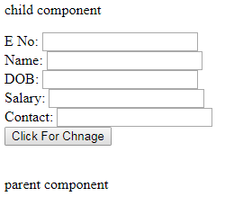 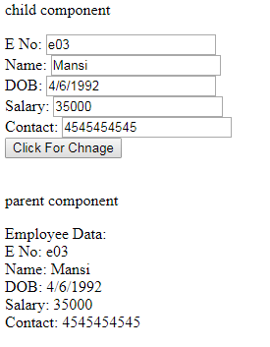

**After Click**

**Child.ts**

import { Employee } from 'src/app/employee';

export class ChildComponent implements OnInit {

@Output() changeMsg=new EventEmitter<Employee>();

eUpdate=new Employee("e02","Beena","2/5/1993",33000,5566556655);

onClick()

{

this.changeMsg.emit(this.eUpdate);

}

**Child.html**

<p>child component</p>

<label>E No: </label>

<input type="text" (input)="eUpdate.eno=$event.target.value"><br>

<label>Name: </label>

<input type="text" (input)="eUpdate.ename=$event.target.value"><br>

<label>DOB: </label>

<input type="text" (input)="eUpdate.eDOB=$event.target.value"><br>

<label>Salary: </label>

<input type="text" (input)="eUpdate.eSalary=$event.target.value"><br>

<label>Contact: </label>

<input type="text" (input)="eUpdate.eContact=$event.target.value"><br>

<button (click)="onClick()">Click For Chnage</button>

**Parent.ts**

import { Employee } from 'src/app/employee';

export class ParentComponent implements OnInit {

myvalue=true

e1=new Employee("e01","Tejas","3/6/1995",35000,7878787878)

onClickChange(e2:Employee)

{

this.e1=e2;

this.myvalue=false

}

**Parent.html**

<app-child (changeMsg)="onClickChange($event)"></app-child>

<br><br>

<p>parent component</p>

<div [hidden] ="myvalue">

Employee Data:

<br>

<label>E No: {{e1.eno}}</label><br>

<label>Name: {{e1.ename}}</label><br>

<label>DOB: {{e1.eDOB}}</label><br>

<label>Salary: {{e1.eSalary}}</label><br>

<label>Contact: {{e1.eContact}}</label><br>

</div>